**Climate Change Spectral Analysis and Time Series Forecasting Final report**

Eloho Okoloko

College of Science and Engineering, Seattle University

DATA 3320 01 Project 3: Climate ChangeFinal Report

Prof. Galen Egan

May 20th, 2024

**Introduction**

Using over 80 years of daily sea surface temperature (SST) data from the South Atlantic ocean basin, the purpose of this project is to examine for evidence of long-term trends such as warming ocean temperatures and more frequent or intense storms. ERA5 is produced by the European Center for Medium-Range Weather Forecasting (ECMWF), widely regarded as the best forecasting center in the world.

**Data Description**

The SST data from the South Atlantic ocean was queried from the ERA5 Reanalysis Product. This dataset combines historical observations with physics based computer models of the earth systems to produce consistent global datasets.

**Data Analysis and Results**

To assist with this analysis, I posed the question: are there discernible trends in the dataset, and if so, can they be projected into the future?After inspecting the rows and columns of the dataset, given that this was a time series, I conducted a spectral analysis, focusing on the power spectral density of the SST with respect to its daily frequency measurements.

Then, I identified a significant peak and trend, noting a distinct annual cycle frequency of 0.00275. It was also identified that this frequency occurred yearly suggesting that this pattern is due to the Earth's orbit around the sun. To further isolate this yearly trend, I applied a Butterworth low-pass filter, which effectively smoothed the data.

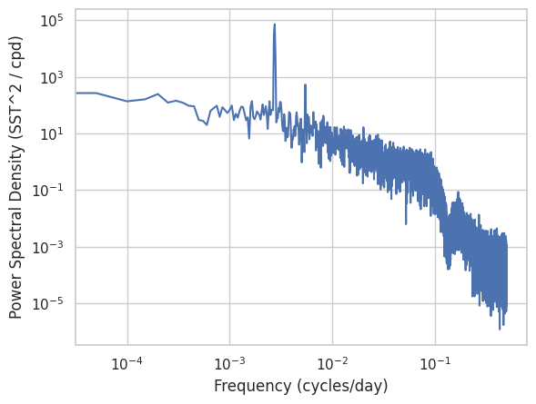

To forecast this trend, I used the Prophet Model Regressor. The forecasting revealed that in 30 years, the SST will not rise above 300k.

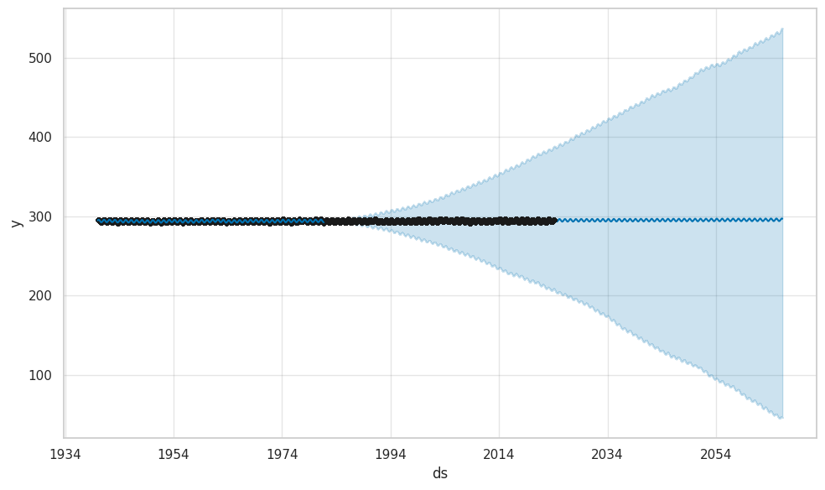

Additionally, I conducted a comparative analysis by creating a second model using the SST signal from the entire dataset. This allowed me to evaluate how predictions using the SST differed from those based solely on the filtered SST signal.

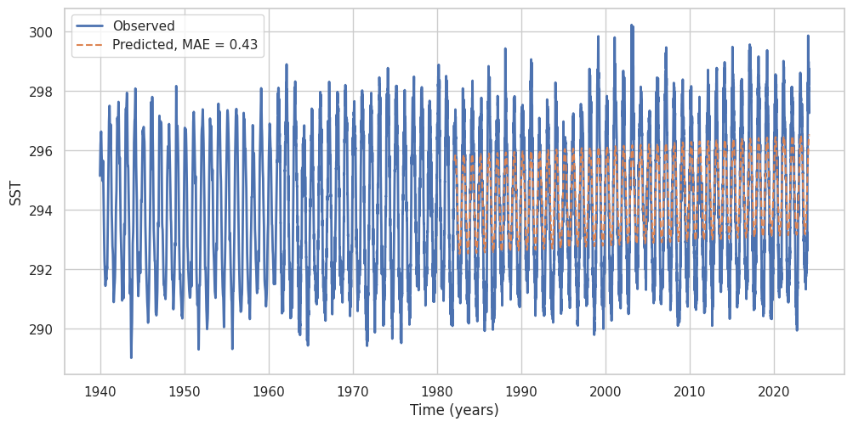

**(Model with filtered SST Signal)**

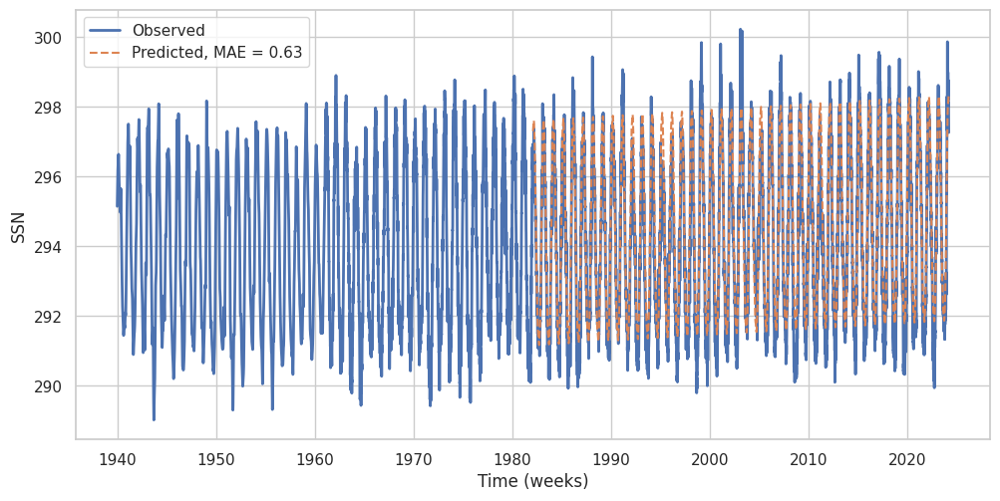

**(Model with unfiltered SST Signal)**

**Conclusion**

The graphs indicate a slight but consistent increase in SST over time, likely attributable to global warming.

In the additional analysis, the model with the filtered signal was better at forecasting the SST into the future. The model with the unfiltered SST values had a mean absolute error (MAE) of 0.63 while the model with the filtered SST had an MAE of 0.43. This shows the importance of filtering and smoothing signals before building predictive models.